Project Design Phase-II
Technology Stack (Architecture & Stack)

Date | 12 October 2026
Team ID | SWTID-2026-5604
Project Name | AI Blognest API
Maximum Marks | 4 Marks

Technical Architecture:
The Deliverable shall include the architectural diagram as below and the information as per the table1 & table 2
Example: AI Blognest API for AI-assisted blog creation, editing, categorization, and publishing
Reference: https://developer.ibm.com/patterns/ai-powered-backend-system-for-order-processing-during-pandemics/
Guidelines:
Include all the processes (As an application logic / Technology Block)
Provide infrastructural demarcation (Local / Cloud)
Indicate external interfaces (third party API’s etc.)
Indicate Data Storage components / services
Indicate interface to machine learning models (if applicable)
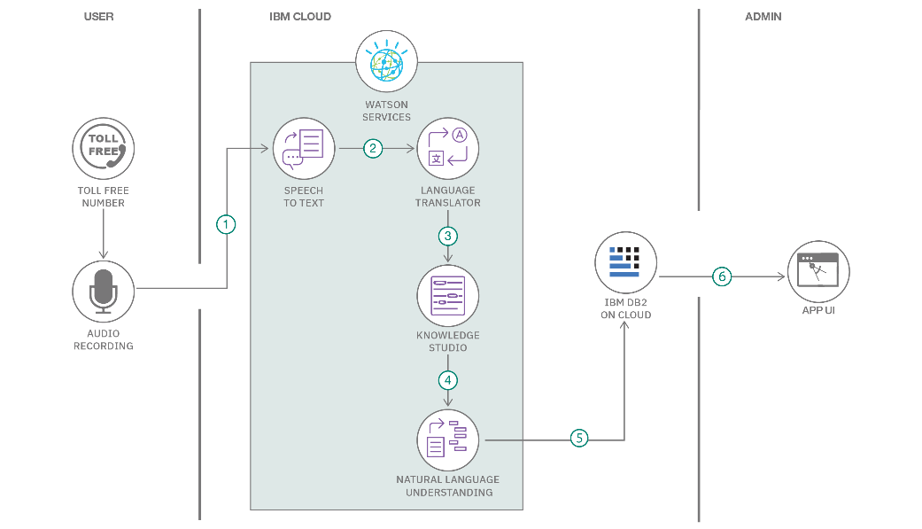

Table-1 : Components & Technologies:
S.No | Component | Description | Technology
 | User Interface | Web interface for creating, editing, previewing, and publishing blog posts | HTML, CSS, JavaScript, React
 | Application Logic-1 | REST endpoints for users, posts, drafts, and publishing workflows | Python, FastAPI
 | Application Logic-2 | Generate blog drafts, titles, outlines, and summaries from prompts | LLM / text-generation API
 | Application Logic-3 | Suggest tags, categories, tone improvements, and content revisions | NLP service / AI content tools
 | Database | Store user profiles, blog posts, drafts, tags, and publishing status | PostgreSQL or MySQL
 | Cloud Database | Managed database for production data and backups | Managed PostgreSQL / cloud database
 | File Storage | Store uploaded images and blog media | Object storage / local development storage
 | External API-1 | Generate and summarize blog content | AI text-generation API
 | External API-2 | Optional email verification and publishing notifications | Email delivery API
 | Machine Learning Model | Topic recommendations, tagging, summarization, and content assistance | Natural language processing model
 | Infrastructure (Server / Cloud) | Host the API and web client with secure configuration and monitoring | Docker, cloud hosting, CI/CD

Table-2: Application Characteristics:
S.No | Characteristics | Description | Technology
 | Open-Source Frameworks | List the open-source frameworks used | Technology of Opensource framework
 | Security Implementations | List all the security / access controls implemented, use of firewalls etc. | e.g. SHA-256, Encryptions, IAM Controls, OWASP etc.
 | Scalable Architecture | Justify the scalability of architecture (3 – tier, Micro-services) | Technology used
 | Availability | Justify the availability of application (e.g. use of load balancers, distributed servers etc.) | Technology used
 | Performance | Design consideration for the performance of the application (number of requests per sec, use of Cache, use of CDN’s) etc. | Technology used

References:
https://c4model.com/
https://developer.ibm.com/patterns/online-order-processing-system-during-pandemic/
https://www.ibm.com/cloud/architecture
https://aws.amazon.com/architecture
https://medium.com/the-internal-startup/how-to-draw-useful-technical-architecture-diagrams-2d20c9fda90d

